RESUME
A.SUSMITHA 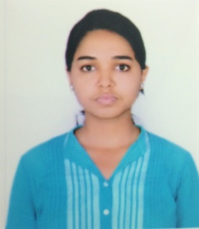
Mobile: 7377094303
email:ayapilla.sushmita1@gmail.com

CAREER OBJECTIVE: To gain employment with a company that offers me a consistently positive atmosphere to learn new technologies and implement them for the betterment of the business.

EDUCATIONAL QUALIFICATION:
- BTech ( Electronics and Instrumentation Engineering)-National Institute of Science and Technology in 2013
- Intermediate (12th) – St. Xavier’s senior secondary school in 2011
- High school (10th) – St. Xavier’s senior secondary school in 2010

PROJECTS:
- Online Health Monitoring System

AWARDS & ACHIEVEMENTS:
- Inter college extempore competition:1st
- Intra college debate competition:2nd
- Engineering talent hunt examination:1st
- Technical Paper presentation:1st

CERTIFICATION COURSES :
- LabVIEW
- Business English Certificate

EXTRA-CURRICULAR ACHIEVEMENTS:
- Singing
- Painting
- Dancing
- Sports

PERSONAL INFORMATION:
- Father’s name - Mr. A.Surya Prakash
- Date of birth - 09-10-1994
- Gender - Female
- Nationality - Indian
- Languages known – English, Hindi, Odia, Telugu
- Address - Vikas Nagar, Near Berhampur University

REFERENCES:
- Manisha Manaswini (Ph.No: 7064265109)

Date: 24-1-2016
Place: Berhampur

SIGNATURE:
